**CMPE 443 PRINCIPLES OF EMBEDDED SYSTEMS DESIGN**

**PRELAB #009 “ADC”**

1. **Problem Definition**

In this prelab, you will use a potentiometer with 3 LEDs. According to the potentiometer value, you will change the LED's state.

* R - G - B LEDs are ON. (Potentiometer Value > 3/4 Max Value)
* G - B LEDs are ON, R LED is OFF. (3/4 Max Value >= Potentiometer Value > 2/4 Max Value)
* B LED is ON, R - G LEDs are OFF. (2/4 Max Value >= Potentiometer Value > 1/4 Max Value)
* R - G - B LEDs are OFF. (1/4 Max Value >= Potentiometer Value)

You will use ADC Interrupt.

1. **Potentiometer**

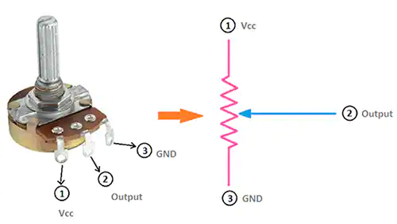

VCC should be connected to the 3.3V of the board. GND is connected to GND. The output of the potentiometer should be connected to a suitable pin you selected.

1. **ADC**

* Which ADC you selected? ADC1
* Which ADC channel you selected Channel 1 - ADC12_IN1
* Which pin you selected? PC0
* Enable Clock for ADC RCC_AHB2ENR |= 1 << 13;
* Select ADC clock as System clock RCC_CCIPR1 |= 11 << 28;
* Change Pin Mode to Analog GPIOC->MODER |= (11);
* Change Pin Pull/Down to no pull-up no pull-down

GPIOC->PUPDR &= ~(11);

* Change Regular channel sequence length to 1 conversion (SQR)

ADC1->SQR1 &= ~(1111);

* Add the channel to first sequence (SQR) ADC1->SQR1 |= (1 << 6);
* Configure for Single conversion mode (CFGR) ADC1->CFGR &= ~(1 << 13);
* Disable Deep-power-down for ADC (CR) ADC1->CR &= ~(1 << 29);
* Enable ADC Voltage regulator (CR) ADC1->CR |= (1 << 28);
* Enable ADC (CR) ADC1->CR |= 1;
* Enable interrupt for end of regular conversion (IER) ADC1->IER |= (1 << 2);
* Start regular conversion of ADC (CR) ADC1->CR |= (1 << 2);

1. **Code**

In this prelab, you need to write code as described at the problem definition.

1. **Submission**

You will submit one zip file which contains this document and your project (all the files with the last configuration)

The naming of the zip file should be:

PRELAB<exp num>_<StudentID>.zip

1. **Related Videos and Links**

ADC:

<https://www.youtube.com/watch?v=DfpyUWQlQKM>

ADC Example Code:

<https://embeddedexpert.io/?p=200>